- 0.25 m3 of Helium gas is contained in a piston cylinder at 125kPa and 350 K. It is then expanded (i.e., volume increases) until the pressure reaches 100 kPa.
- Assess the final temperature if it is expanded following a constant temperature process.
- Determine the work if the expansions is done using a constant temperature process.
- Assess the final temperature if the gas is expanded using a polytropic process with coefficient n=1.667
- Assess the work for the expansion in part (c).
- Sketch the complete P-v diagram from the constant temperature expansion from state 1 to state 2. On the same sketch include the alternative expansion using a polytropic process.

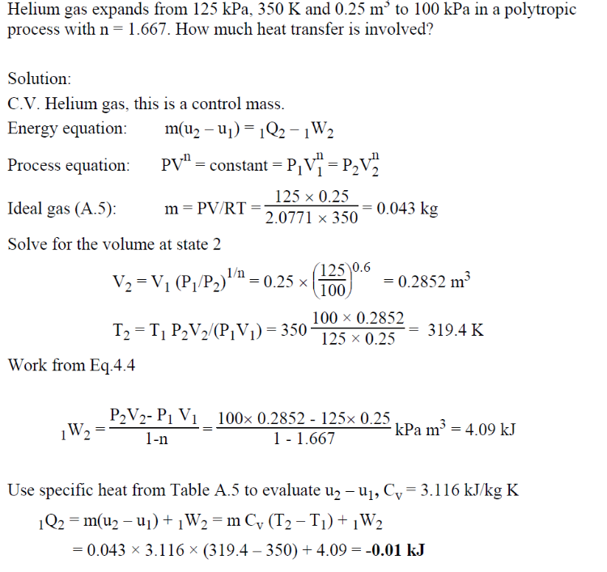

- A piston cylinder system is initially at rest with the piston head floating on 1kg of water which is initially at 20 C and 300 kPa. The cylinder is equipped with stops at the top which prevent the cylinder head from rising once the volume reaches 0.002m3. The system is heated until the pressure reaches 600 kPa.
- Determine the initial specific volume and initial specific internal energy in the cylinder.
- Determine the specific volume ad temperature when the piston first touches the stops at the top of the cylinder.
- Determine the final specific volume and final specific internal energy when the system reaches 600 kPa.
- Determine the specific work over the entire heating process.
- Using the first law, assess heat transferred per unit mass (specific heat transferred in kJ/kg), over the entire heating process.
